Assessment: Lab 3

Student Name: Zahi Masarwa

Lab Professor Name: *Mel Sanschagrin*

Lab Section Number: *303*

Due Date: 02/15/2021

# **UML Class Design**

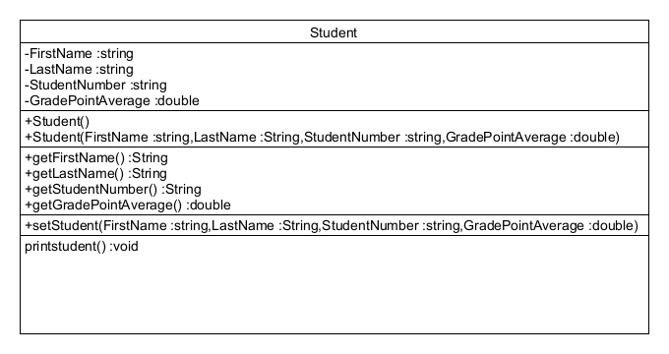

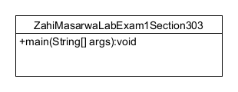

# **Screen shot executing program**

